COPD

Contents

Y6Y16-cuối kì nội đợt 1-full 1

y6y16-cuối kì nội-đợt 2 1

y6y16-cuối kì nội-đợt 3 2

Y6Y16-cuối kì nội-đợt 4 2

# Y6Y16-cuối kì nội đợt 1-full

# y6y16-cuối kì nội-đợt 2

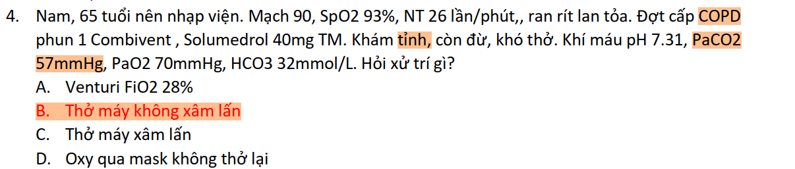

# y6y16-cuối kì nội-đợt 3

# Y6Y16-cuối kì nội-đợt 4

